POUSHALI SAHA

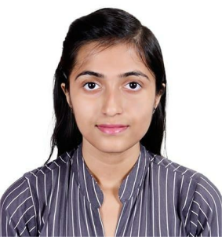

**B.Tech 4th Year |Electronics and Telecommunication Engineering**

**A dedicated and innovative Electronics and Telecommunication Engineering student with a strong passion for technology and problem-solving. Continuously seeking opportunities to learn, grow, and contribute to impactful projects.**

# CONTACT

+91 8981456932

[poushali2923@gmail.com](mailto:poushali2923@gmail.com) [github.com/Poushali-saha](https://github.com/Poushali-saha) linkedin.com/in/54nd49

# EDUCATION

**PROJECT WORKS**

## [SMART MIRROR AS VIRTUAL DRESSING ROOM](https://github.com/54nd339/ML_DA/blob/master/GAN/GAN.ipynb)

* **Developing the **software and technological framework**** for a **Smart Mirror as a Virtual Dressing Room**, integrating ****AI, AR, and IoT**** for real-time virtual clothing try-ons.
* Innovating the **coding and AI-driven functionalities**, focusing on **body scanning, generative AI models, and real-time visualization** to enhance accuracy and interactivity.

## [SMART MIRROR AS VIRTUAL DRESSING ROOM](https://github.com/54nd339/ML_DA/blob/master/GAN/GAN.ipynb)

Hhhhhh

hhh

**Kalinga Institute of Industrial Technology Deemed University,Bhubaneswar, Odisha**

2022-Present

CGPA as in 6th semester - 7.92

**Christ Church Girls’ High School,Kolkata, West Bengal**

2022

Class 12th Percentage - 79.3%

**Christ Church Girls’ High School,Kolkata, West Bengal**

2020

Class 10th Percentage - 89.4%

**CERTIFICATIONS**

* Embedded System Training from TeachNook - Certificate URL
* Raspberry Pi Masterclass from Pantech e Learning - Certificate URL
* K-I3 Fest Participation Certificate - Certificate URL
* AMCAT Exam Completion Certificates - Certificate URL
* CodeSprint : 30 Days Coding Challenge - Certificate URL
* “Industry 4.0 and Emerging Technologies” Tech talk - Certificate URL
* Tableau Workshop from Jobaaj - Certificate URL
* AI Tools Workshop from be10X - Certificate URL
* NSS District Level Neighbourhood Youth Parliament - Certificate URL